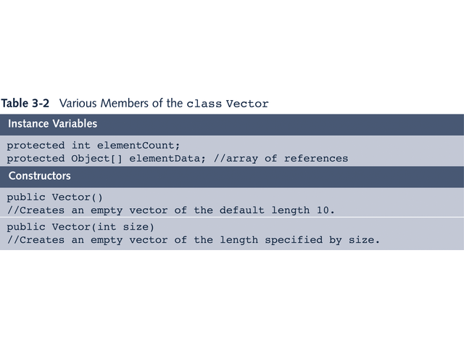

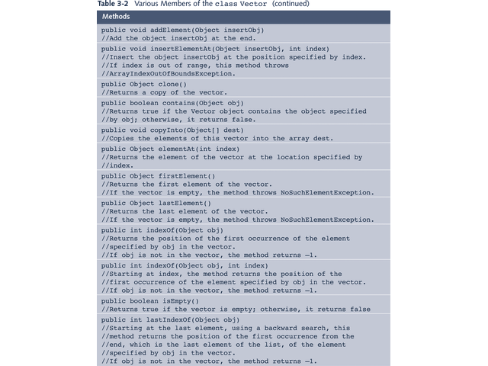

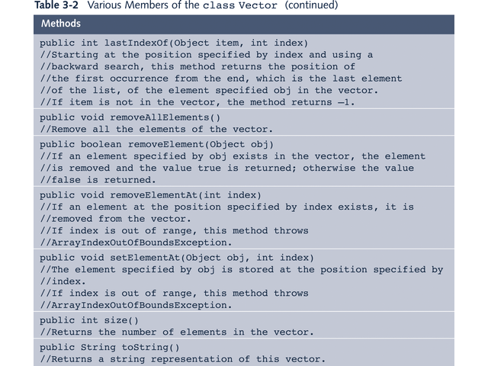

1. Every element of Vector object is reference variable of type Object

2. To add an element into Vector object
–Create appropriate object
–Store data into object
–Store address of object holding data into Vector object element

